Somerset Social Media Toolkit
━━━━━━━━━━━━━━━━━━━━━━━━━━━━━━━━━━━━━━━━━━━━

Toolkit Information

Registration Link
https://somerset.mydiabetes.com

Contact
somerset@mwdh.co.uk

Language Matters Guidance
The captions have been developed using NHS and Language Matters guidance. If you choose to adapt the captions, we encourage you to review the latest guidance:
https://www.england.nhs.uk/long-read/language-matters-language-and-diabetes/

Using This Toolkit
• Please ensure the caption headline matches the headline shown on the graphic.
• Please use the Somerset registration link when publishing content.
• You may wish to use all assets as part of a campaign or select the graphics that best reflect your local population.
• You are welcome to adapt the captions to suit your own tone of voice and local communication channels.
━━━━━━━━━━━━━━━━━━━━━━━━━━━━━━━━━━━━━━━━━━━━

Instructions
This pack contains social media graphics and suggested captions to help promote MyWay Diabetes to people living with diabetes in Somerset.
The graphics have been designed to represent a diverse range of people and experiences. You may wish to use all assets as part of a campaign or select the graphics that best reflect your local population and communication objectives.
Kind regards,
The MyWay Diabetes Team
info@mwdh.co.uk

Social Media Captions
Each example graphic below is matched to the suggested caption that follows it.

Header 1 – Your diabetes information, in one place
Example Graphic  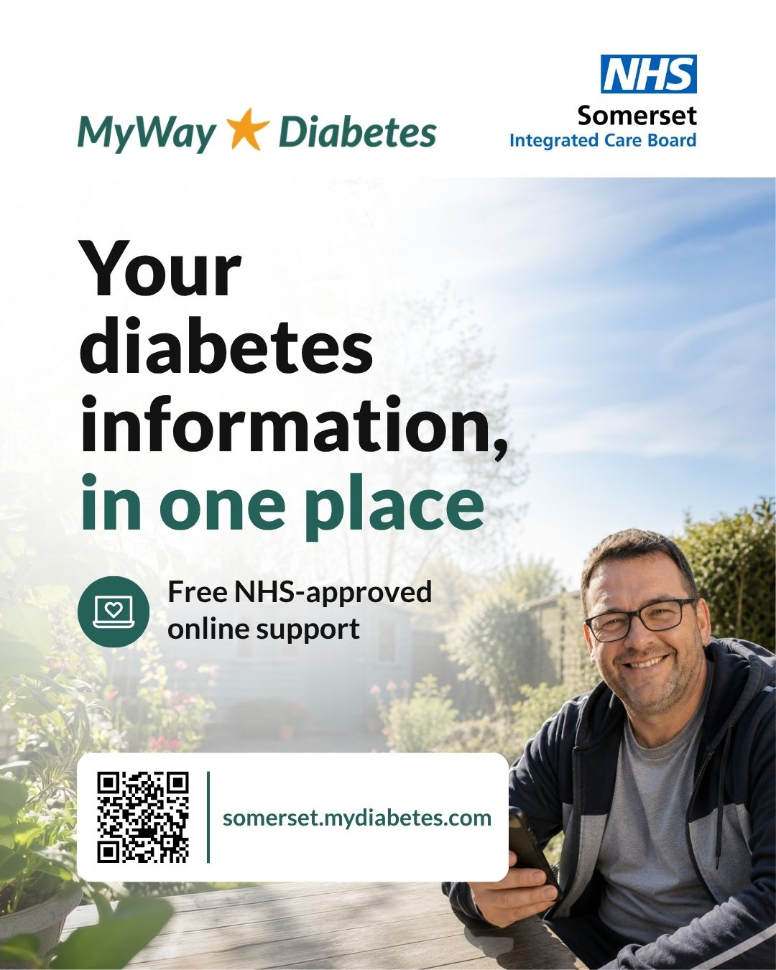 | Suggested Caption  Living with diabetes?  MyWay Diabetes is a free NHS-approved online service available to people living with diabetes in Somerset.  You can access your diabetes information in one place, view your results over time and explore tools and resources to support your diabetes self-management.  Available online whenever it suits you.  Find out more and register today:  https://somerset.mydiabetes.com  #MyWayDiabetes #DiabetesSupport

Header 2 – Learn more about living with diabetes
Example Graphic  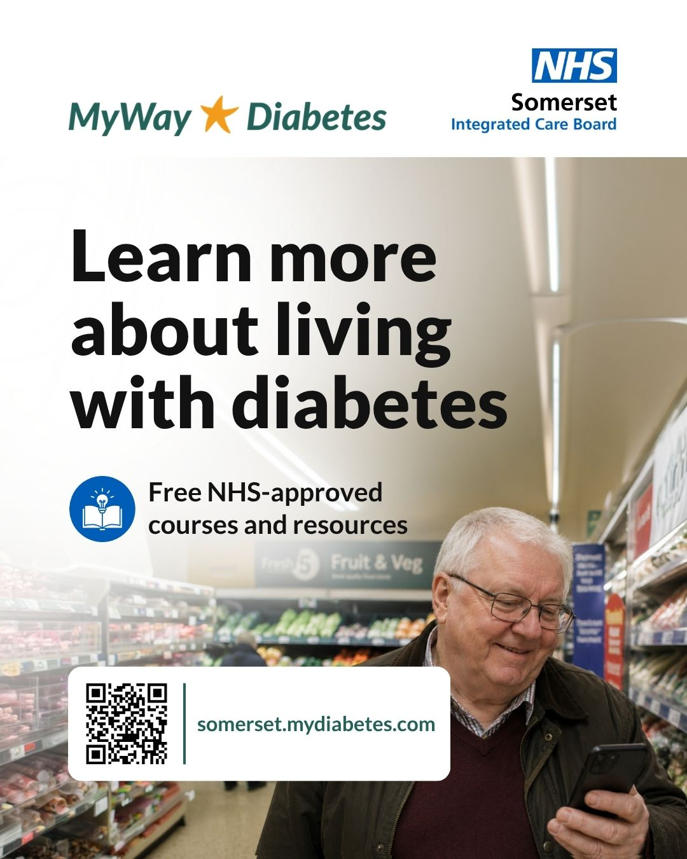 | Suggested Caption  Living with diabetes?  MyWay Diabetes is a free NHS-approved online service available to people living with diabetes in Somerset.  Access free NHS-approved courses and resources designed to help you learn more about living with diabetes. Learn at your own pace, wherever and whenever it suits you.  Find out more and register today:  https://somerset.mydiabetes.com  #MyWayDiabetes #DiabetesSupport

Header 3 – Support beyond your appointments
Example Graphic  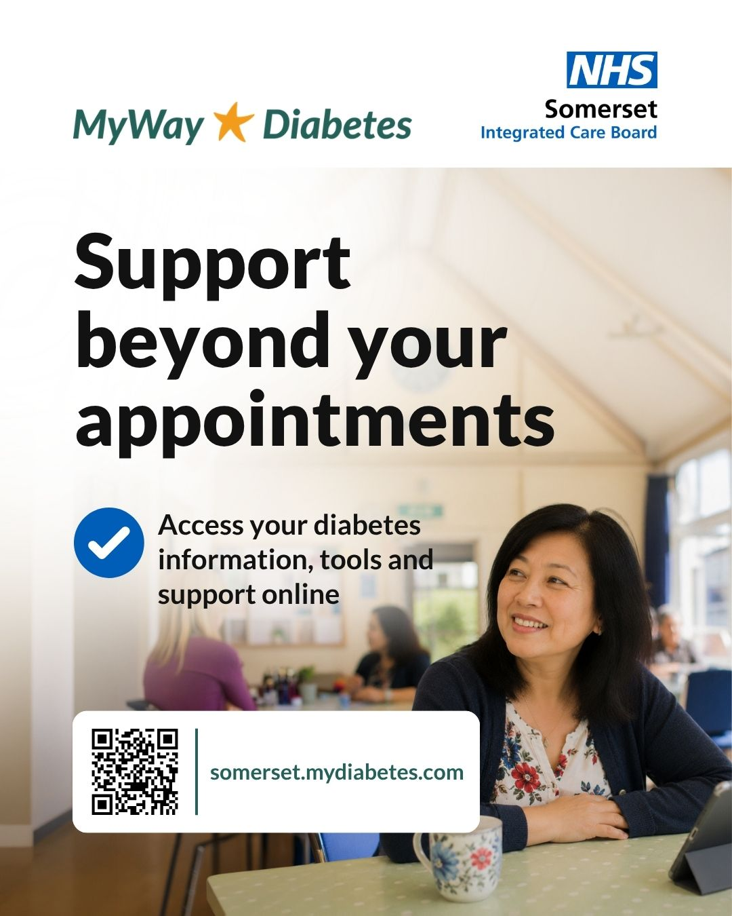 | Suggested Caption  Living with diabetes?  MyWay Diabetes is a free NHS-approved online service available to people living with diabetes in Somerset.  Access your diabetes information, tools and support online between appointments. Track your progress over time, set goals that matter to you and access trusted NHS-approved resources in one place.  Find out more and register today:  https://somerset.mydiabetes.com  #MyWayDiabetes #DiabetesSupport

