 | 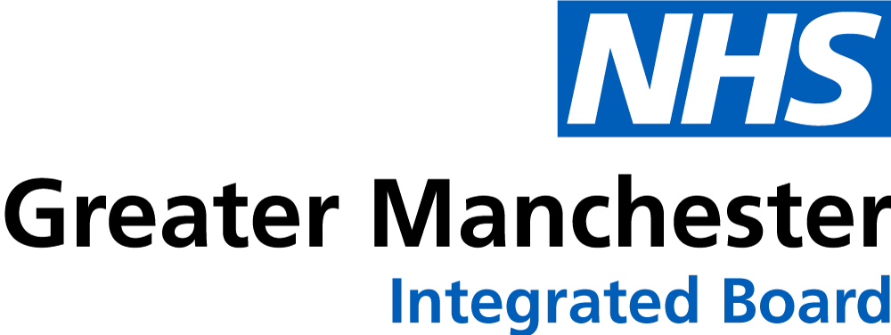
<Date> | GP Name  GP Practice Code  GP Address  GP Postcode

Dear <Patient Name>
As someone living with diabetes, you may be interested in MyWay Diabetes, a free online platform available across Greater Manchester.
MyWay Diabetes brings together your diabetes health information, self-management tools and NHS-approved educational resources in one secure place, helping you better understand your diabetes and access support that works for you.
With MyWay Diabetes, you can:
- View your diabetes health information in one place
- Track your results and monitor changes over time
- Access NHS-approved educational resources and online courses
- Set goals and build healthy routines to support your diabetes self-management
- Access information and support when it suits you
- Find resources available in a range of languages
Many people using MyWay Diabetes tell us that it helps them better understand their diabetes, prepare for appointments and feel more confident managing their condition alongside their healthcare team.
The platform includes a wide range of NHS-approved educational resources and online courses covering type 1 diabetes, type 2 diabetes, gestational diabetes, diabetes prevention, type 2 diabetes remission, physical activity and diabetes technologies. You can learn at your own pace and return whenever you need support.
MyWay Diabetes is designed to support, not replace, the care you receive from your GP practice and diabetes specialists.
To register, simply visit:
diabetesmyway.nhs.uk
and select "Register" to sign in securely using your NHS Login.
If you would like to find out more before registering, please contact the MyWay Diabetes team at:
manchester@mwdh.co.uk
We hope you find MyWay Diabetes helpful and encourage you to explore the free resources, education and support available.
Yours sincerely,
<Practice Name>

